**CS 2265 - Advanced Programming I (using Java)**

**Program #1 Solution**

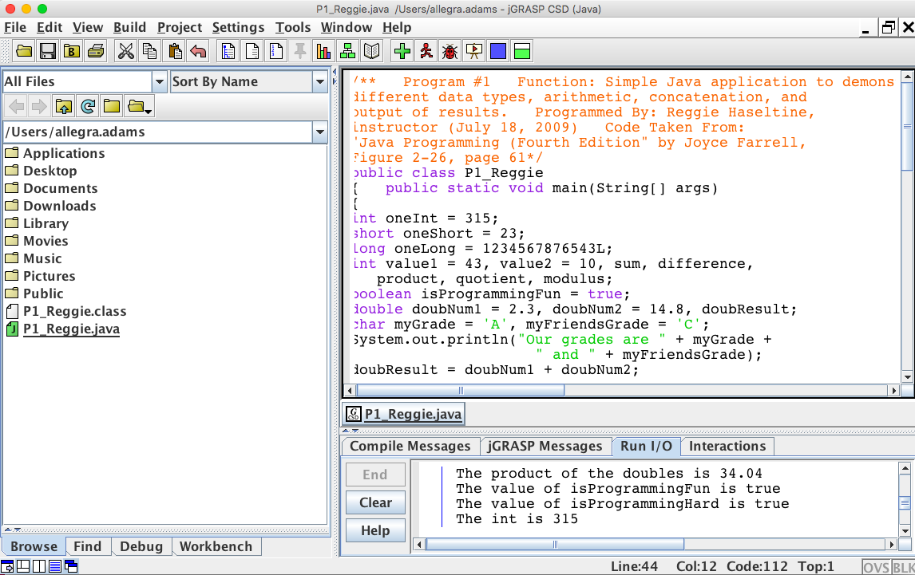

/**

   Program #1

   Function: Simple Java application to demonstrate the behavior of different data types, arithmetic, concatenation and output results

**Programmed by: Allegra Adams (October 27, 2018)**

**Code Taken From: “Java Programming (Fourth Edition” by Joyce Farrell)**

**Figure 2-26, page 61**

*/

public class P1_Reggie

{

   public static void main(String[] args)

   {

      int oneInt = 315;

      short oneShort = 23;

      long oneLong = 1234567876543L;

      int value1 = 43, value2 = 10, sum, difference,

          product, quotient, modulus;

      boolean isProgrammingFun = true;

      double doubNum1 = 2.3, doubNum2 = 14.8, doubResult;

      char myGrade = 'A', myFriendsGrade = 'C';

      System.out.println("Our grades are " + myGrade +

                        " and " + myFriendsGrade);

      doubResult = doubNum1 + doubNum2;

      System.out.println("The sum of the doubles is " +

                         doubResult);

      doubResult = doubNum1 * doubNum2;

      System.out.println("The product of the doubles is " +

                         doubResult);

      System.out.println("The value of isProgrammingFun is " +

                         isProgrammingFun);

      System.out.println("The value of isProgrammingHard is " +

                         isProgrammingFun);

      System.out.println("The int is " + oneInt);

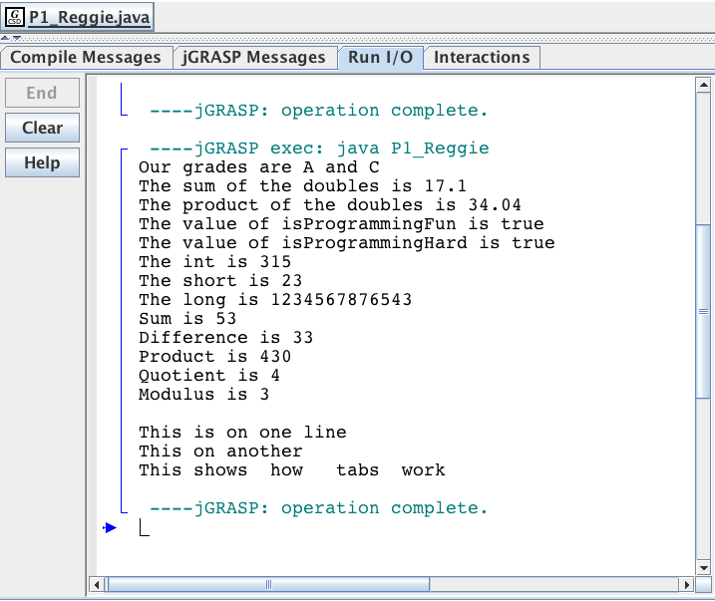

      System.out.println("The short is " + oneShort);

      System.out.println("The long is " + oneLong);

      sum = value1 + value2;

      difference = value1 - value2;

      product = value1 * value2;

      quotient = value1 / value2;

      modulus = value1 % value2;

      System.out.println("Sum is " + sum);

      System.out.println("Difference is " + difference);

      System.out.println("Product is " + product);

      System.out.println("Quotient is " + quotient);

      System.out.println("Modulus is " + modulus);

      System.out.println("\nThis is on one line\nThis on another");

      System.out.println("This shows\thow\ttabs\twork");

   } // end method main

}  // end class P1_Reggie